**ALL INDIA RESEARCH SCHOLARS’ SUMMIT - 2024**

**INDIAN INSTITUTE OF TECHNOLOGY MADRAS, INDIA**

**I PREFER: ORAL PRESENTATION**

**SMART SELF-MOVING CHAIRS**

**A. Abstract:**

Author: Jay Soni

Lead Presenter: Jay Soni

E mail address of lead presenter: [jaysoni0306@gmail.com](mailto:jaysoni0306@gmail.com)

Institution: Chitkara University , Punjab , India

In educational institutes such as computer, science labs, etc. there is a constant need to rearrange chairs as students and teachers visit repeatedly has been a persistent challenge. There is a solution required which reduces the effort and also keeps the space neat and clean. I am solving this problem by researching on self moving chairs which automatically adjust themselves near students’ and teachers’ desks and simplifies chair arrangement procedure.

This solution incorporates robotics technology, natural language processing (NLP), and Internet of Things (IoT) to change the traditional chair arranging. The chairs that are not in use can go their proper position using robotics, removing any manual intervention. NLP functionality further enhances user interaction by allowing students to communicate through specific instructions to the chairs, making seamless adjustments based on individual preferences or requirements. Moreover, integration of IoT technology ensures proper spacing between chairs.

The key components include microchips, sensors, memory units and wheels . Microchips provide the computation power that is important for running all commands, sensing chair location, tracking surroundings, and coordinating chair movement. Sensors enables the chairs detect obstacles in the environment. Memory units store the important data related to position of the chairs and preference of the user, ensuring consistency and efficiency in the process.

These chairs are versatile when it comes to its uses. Firstly, it reduces manual effort related to chair management, allowing students and teachers to be more productive. Secondly, implementation of these chairs would result in a tidier and more organised environment improving aesthetics and functionality. In conclusion, innovation of smart self moving chairs represents a pioneering approach to addressing challenges of chair management. By using the power of robotics, NLP and IoT , this research not only streamlines process of chair management but also enhances overall user experiences. With this research’s potential to revolutionize workspace dynamics, our invention holds promise for widespread adoption in educational institutions and beyond.

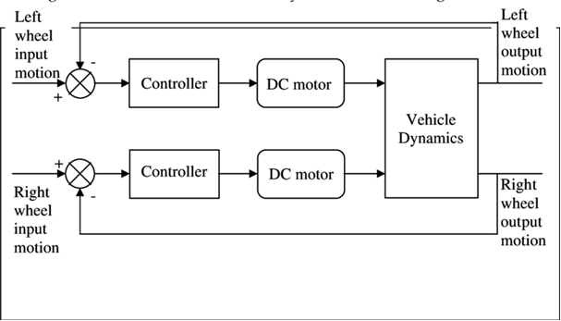

**B. Justification with Atmanirbhar Bharat:**

This research promotes self reliance by innovating smart self moving chairs, fostering technological advancement and economic growth for our country. Hence, it aligns with the theme of "Catalysing Innovation: Uniting Industry and Academia for Atmanirbhar Bharat."